July 16, 2024

Hello family history researchers,

I have been enjoying listening to a new podcast while in my car. This podcast is only a few months old. It is called “Stories That Live In Us” by Crista Cowan. Crista is the corporate genealogist for Ancestry and is known as the Barefoot Genealogist. Each episode of the podcast features Crista interviewing someone with a family history story. She starts out the first episode with her own story of the determination that she found to keep her word to her grandfather. In each episode thereafter, there is an interesting take on how each person got interested in finding out more about their own family history. Right now there are fifteen episodes that have been delivered. After I listen to each one, I hopefully look at the episode list, wanting to see if there are any more that I haven’t heard yet. Crista Cowan is a great storyteller and this new podcast will not disappoint. Available anywhere you get your podcasts.

Willard Library is planning for its first ever Genealogy Quest, September 10-13, 2024. This takes the place of Midnight Madness that we have known at Willard for many years. Speakers include Katherine Schober, Peggy Lauritzen, Lisa Louise Cooke along with local experts. For information on the schedule, hours, and sign up, go to the Willard Library website and click on “Genealogy” and then 2024 Genealogy Quest ([www.willardlib.org](http://www.willardlib.org)).

This past Sunday, the board of Tri State Genealogical Society had a meeting to discuss our plans for the 2024-2025 program year. We will soon be announcing plans that have been made thus far. Here’s a pic of your board at work.

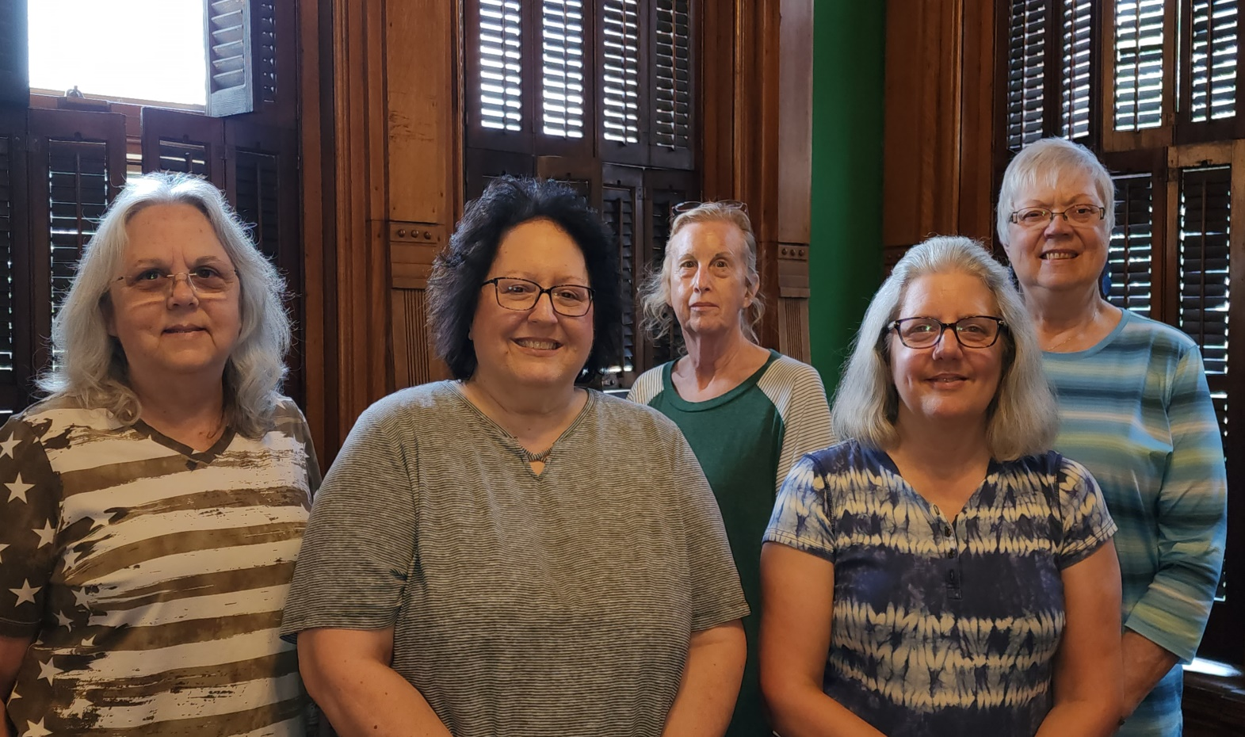

Talk to you soon,

Kim Van Vorst

President, Tri State Genealogical Society